Eric Dockery | October 21, 2013

CECS 220

Assignment #4

# Programming Project 7.3

Design and implement a class called **Course** that represents a course taken at a school. A course **object should keep track of up to five students**, as represented by the modified **Student class** from the previous programming project. The constructor of the Course class should accept only the **name of the course**. Provide a method called **addStudent** that accepts **one Student parameter** **(the Course object should keep track of how many valid students have been added to the course)**. Provide a method called **average** that **computes and returns the average of all students’ text score averages**. Provide a method called **roll that prints all students in the course**. Create a driver class with a main method that creates a course, adds several students, prints a roll and prints the overall course test average.

How to solve:

First step on this assignment is to modify the Student Class from the last program assignment. After doing the correct modifications I shortened the Student Class to not include the address for the student do to the amount of time it was taking to add all of it onto the driver. Next I created the Course class and it was quite a pain to get correct until I implemented an Array. In the array I added the students one at a time, and if there are too many students added to the array it will error out when the roll is called. This was a pretty complex problem and I have been working on it for a couple of days trying to understand everything that I should with calling the classes and implementing the correct information. Before I used an Array I was trying to use a set of if statements for each student that was added but I couldn’t seem to get the logic in place for each student to work correctly. I am not sure that the code for this is 100% correct but this is the best solution that I could come up with.

Screenshots:

Added 5 students then printed the roll, then added one more and reprinted roll

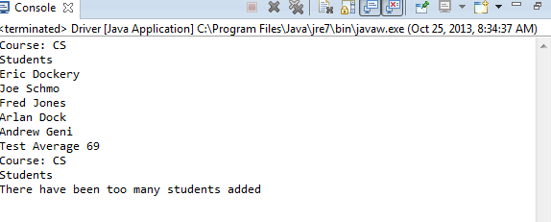

Programming Project 7.5

Desing a Java interface called Priority that includes two methods: setPriority and getPriority. The interface should define a way to establish numeric priority among a set of objects. Design and implement a class called Task that represents a task (such as on a to-do list) that implements the Priority interface. Create a driver class to exercise some Task objects.

How to solve:

This problem was challenging because I kept trying to overcomplicate what it was asking for. For this programming project you just need to set a simple interface called Priority that has the two methods setPriority and getPriority. Then build the Class Task. In Task you have the two methods for my example I had the setPriority increment the priority of the data by 3. Then create the Driver for the Task. I named mine PriorityDriver before I realized that this was incorrect. In the PriorityDriver I created Task New_Task = new Task(); and then set it with New_Task.setPriority(-2); and had the IDE print it out along with a message of what New_Task would be. (Example in the screenshots.

Screenshots:

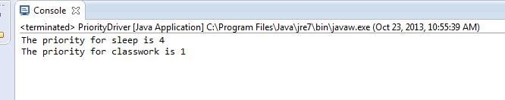

Programming Project 7.10

Redesign and implement a version of the PigLatin program so that it uses a GUI. Accept the sentence using a text field and display the results using a label.

How to solve:

In solving this problem the first step would be to take the PigLatin program and edit it to form a JFrame from and pull all the Gui information and the Translator in one Class I called TranslatorGUI. In my TranslatorGUI the first step is to pick the Layout Manager. For my program I chose a Box Layout with vertical alignment so that everything could be easily viewed. I then made the JTextField and a JButton for the translation. The JButton has a listener that when pressed will add the translated JLabel on the frame. I also colored the backdrop of this program pink that reminds me of the color of cartoon pigs.

Screenshots:

Before text entered:

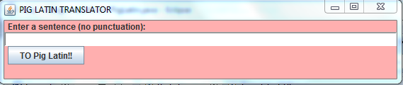

After text entered:

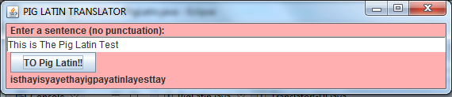

Programming Project 7.13

Design and implement a program that displays a numeric keypad that might appear on a phone. Above the keypad buttons, show a label that displays the numbers as they are picked. To the right of the keypad buttons, include another button to clear the display. Use a border layout to manage the overall presentation, and a grid layout to manage the keypad buttons. Put a border around the keypad buttons to group them visually and a border around the display.

How to solve:

The best way to solve this problem is to break it down into components and once each gui component is finished then add them together. First I will build the keypad buttons using grid layout. Then I will build the display and set up the listener for each of the buttons. Then I will place the display and buttons in a separate borders then put those borders in a border. This is a very involved process and will take some time so there will probably be quite a few screenshots. One thing I would have liked to add to this is a pause that would auto clear when the format for call was incorrect but because we haven’t covered it and I was having trouble understanding the correct form for Java I was unable to include it in the program.

Screenshots:

First keypad test:

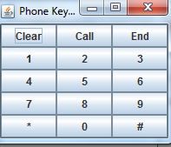

Can only get one key on atm trying to figure out what is wrong

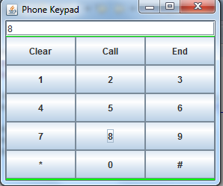

Got help from Professor with Issue. Was initializing by key to “” every time it ran a button process. Added borders.

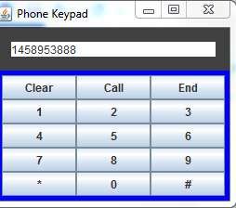

Added a calling function display to the current build

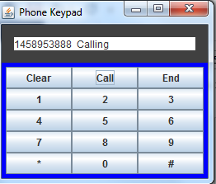

End call shows on display

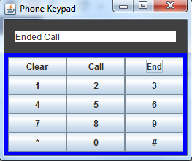

Missing area code before and after

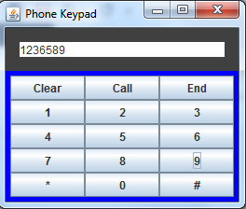

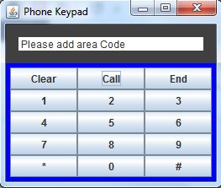

Wrong phone number digits

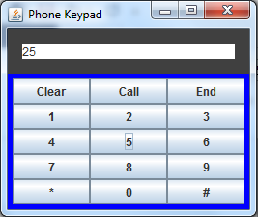

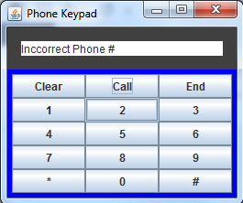

* Note must clear after messages because pause function hasn’t been discussed.